May 15, 2023

Company Name: Nippon Paper Industries Co., Ltd. Representative: Toru Nozawa, President
Stock Code 3863, Prime Market of TSE

Nippon Paper Announces Revisions of Numeric Targets for "2030VISION" and "Medium-Term Business Plan 2025"

Nippon Paper Industries Co., Ltd. (Tokyo: 3863; President: Toru Nozawa; the "Company") has decided to revise some numerical targets for "2030VISION" and "Medium-Term Business Plan 2025" announced on May 14, 2021 and the Company is pleased to announce it as follows.

- Background and Reasons for the Review
Nippon Paper Group's 2030VISION set a target of reducing GHG emissions by 45% from fiscal year ended March 31, 2014 and has been promoting coal usage reductions, fuel-conversions, and energy savings. As a consequence, the Company is able to reach its initial target. In light of this progress, the Company considered additional measures linked to reorganization of production structure in the graphic paper business. As a result, the Company have seen a path for further reductions, therefore the Company will revise its target for fiscal year ending March 31, 2031 to "reduce GHG emissions by 54% from fiscal year ended March 31, 2014" As social demands for reducing GHG emissions is expected to increase in the future, the Company will continue to work with reorganization of production structure of domestic graphic paper to further reduce GHG emissions, such as by stopping coal boilers and converting to high efficient recovery boilers. The Company will continue to take on new challenges to realize carbon neutral in 2050 and contribute to the realization of circulation-oriented society.
In Medium-Term Business Plan 2025, under the theme of "Accelerate the transformation of the business structure", the Company have invested in growth business, centered on Daily-Life Products Business, to develop high-value-added products and differentiated products, and to expand production capacity. Consequently, net sales achieved the initial target of its Medium-Term Business Plan 2025 in fiscal year ended March 31, 2023. Therefore, the Company will review net sales target of Medium-Term Business Plan 2025 to ¥1.2 trillion or more, since net sales is expected to expand as it continues to realize the benefits of investment.
Meanwhile, during the two years following the start of Medium-Term Business Plan 2025, various costs, including raw material and fuel prices and logistics costs, rose significantly due to unstable international conditions and the ongoing worldwide inflation. In response to these changes in the business environment, the Company have implemented cost reductions, such as reducing fixed costs including shutdowns of manufacturing equipment and reducing coal consumption, as well as price increase in a wide range of products. At the same time, the Company aggressively disposed of strategic hold stocks and idle assets with carefully selection of capital expenditures to reduce the amount of investment. However, the Company have not yet rebuilt its financial position to the originally planned level. Accordingly, the Company will revise its net debt/equity ratio target of Medium-Term Business Plan 2025 to 1.7 times.
At 2030VISION and Medium-Term Business Plan 2025, Nippon Paper Group is keenly aware that raising corporate value is a top priority of its assignments for meeting shareholders’ expectation. Accordingly, ROE target has been established as an indicator for achieving a certain level of return on equity. At present, this is a transitional period for business restructuring, and the Company is not able to fully meet the expectations of its shareholders. However, in terms of net sales structure, net sales ratio other than Paper and Paperboard Business exceeded 50% for the first time in fiscal year ended March 31, 2023, and the Company is making steady progress in business restructuring, which is a theme of Medium-Term Business Plan 2025, and ROE target remains unchanged from its initial forecast. In order to accelerate business restructuring, Nippon Paper Group will appropriately invest in growth business in line with increase of demand in the market, while fully considering financial discipline.
In 2021, Nippon Paper Group undertook a major change in management consciousness as a concrete measure to transform its business structure. In Paper and Paperboard Business, the sales division is now responsible for the bottom line, replacing mills, which has long been positioned as a profit center. Last year, the Company outlined its vision for the future of concentrating domestic graphic paper production site in about three locations by 2030. With regard to its medium-to long-term initiatives, the Company have fostered an awareness that it will adopt measures by back-casting them from the 2030Vision.
In terms of initiatives related to its organizational structure, the Company have selected Chief Officers who are intertwined across the entire Nippon Paper Group in the fields of raw materials, technology, R&D, and logistics in order to clarify the framework for steadily promoting measures to deal with critical management challenges, even in the face of drastically changing business conditions. The Chief Officers make regular quarterly reports to the Director Committee, which also serves as a supervisory function of the Director Committee. In addition, Outside Directors attend internal meetings such as Nippon Paper Group Management Committee and receive information-sharing, thereby increasing the number of opportunities who look at the entire Nippon Paper Group and express their opinions. In this way, the Company is strengthening its governance system.
Through these initiatives, the Company will deepen discussions on progress, challenges, and future strategies. The Company will realize the achievement of 2030VISION and Medium-Term Business Plan 2025 and pursue the enhancement of its corporate value.
2.Details of Revision

Targets of 2030VISION

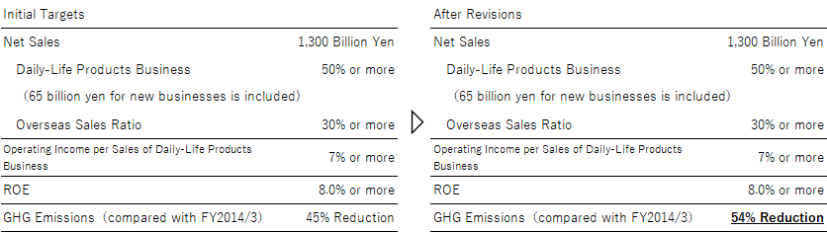

Targets of Medium-Term Business Plan 2025

